1
<!DOCTYPE html>
<html lang="en">
<head>
<title>Google</title>
<link rel="stylesheet" href="style.css">
</head>
<body>
<div id="google" >
<div id="g1">G</div>
<div id="o1">o</div>
<div id="o2">o</div>
<div id="g2">g</div>
<div id="l">l</div>
<div id="e">e</div>
</div>
<div id="input">
<input type="text" id="box">
</div>
<div id="india"><span>India</span></div>
<div id="button">
<button>Google Search</button>
<button>I'm Feeling Lucky</button>
</div>
</body>
</html>

#google{
display: flex;
justify-content: center;
font-size: 80px;
}
#g1{
color: blue;
}
#o1{
color: red;
}
#o2{
color: yellow;
}
#g2{
color: blue;
}
#l{
color: green;
}
#e{
color: red;
}
#box{
margin-left: 420px;
margin-top: 10px;
width: 500px;
}
#india{
margin-left: 746px;
margin-top: -47px;
font-size: 20px;
}
#button{
margin-left: 567px;
margin-top: 35px;
}

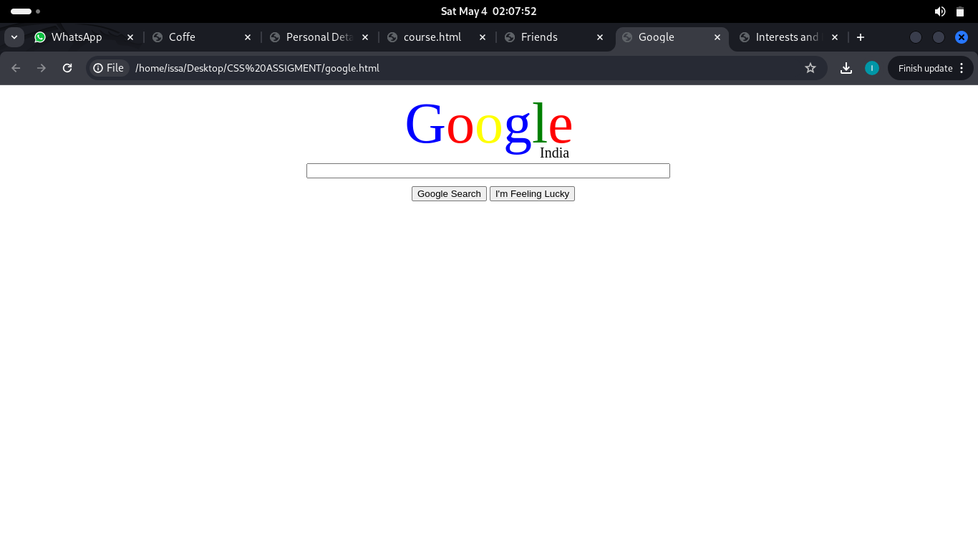

2

<!DOCTYPE html>
<html lang="en">
<head>
<title>Coffe</title>
<link rel="stylesheet" href="kahawastyle.css">
<meta charset="UTF-8">
<meta name="viewport" content="width=device-width, initial-scale=1.0">
</head>
<body>
<div>
<p>
Coffee is a brewed drink with a distinct aroma and flavor, prepared from roasted coffee beans, the seeds found inside<br>
"berries" of the Coffea plant. Coffee plants are cultivated in over 70 countries, primarily in equatorial Latin America,<br>
Southeast Asia, India and Africa. The two most commonly grown are the highly regarded arabica, and the less <br>
sophisticated but stronger and more hardy robusta. The latter is resistant to the coffee leaf rust, Hemileia vastatrix,<br>
but has a more bitter taste. Once ripe, coffee beans are picked, processed, and dried. Green (unroasted) coffee beans<br>
are one of the most traded agricultural commodities in the world. Once traded, the beans are roasted to varying <br>
degrees, depending on the desired flavor, before being ground and brewed to create coffee. Coffee is slightly acidic and can have a <br>
stimulating effect on humans because of its caffeine content. It is one of the most popular drinks in the world. It can be prepared and <br>
presented in a variety of ways. The effect of coffee on human health has been a subject of many studies; however, results have <br>
varied in terms of coffee's relative benefit. The majority of recent research suggests that moderate coffee consumption is benign or <br>
mildly beneficial in healthy adults. However, the diterpenes in coffee may increase the risk of heart disease
</p>
</div>
<div>
<img src="kahawa.jpeg">
</div>
</body>
</html>

img{
width: 90px;
height: 80px;
margin-left: 755px;
margin-top: -210px;
position: absolute;
border: 2px solid rgb(87, 79, 79);
}

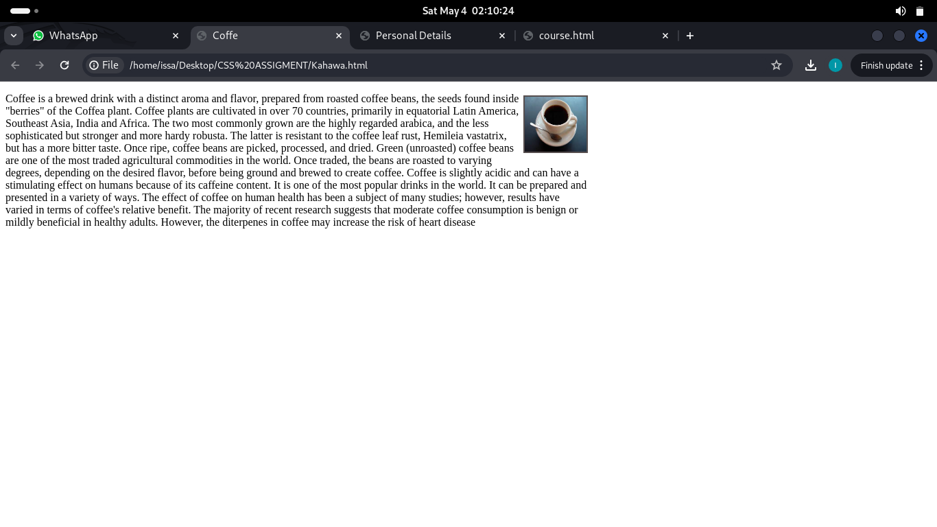

3
<!DOCTYPE html>
<html>
<head>
<title>Personal Details</title>
<link rel="stylesheet" type="text/css" href="pstyle.css">
</head>
<body>
<header>
<h1>Welcome to My Personal Webpage</h1>
</header>
<nav>
<ul>
<li><a href="Personal.html">Personal Details</a></li>
<li><a href="interest.html">Interests and Hobbies</a></li>
<li><a href="friend.html">Friends</a></li>
</ul>
</nav>
<main>
<h2>Personal Details</h2>
<table border="2">
<tr>
<td><strong>Name:</strong></td>
<td>Issa Ahmed Suleiman</td>
</tr>
<tr>
<td><strong>Age:</strong></td>
<td>25</td>
</tr>
<tr>
<td><strong>Location:</strong></td>
<td>Zanzibar, Tanzania</td>
</tr>
</table>
<br>
<img src="kahawa.jpeg" alt="My Profile Picture">
</main>
<footer>
&copy; 2024 My Personal Webpage. All rights reserved.
</footer>
</body>
</html>

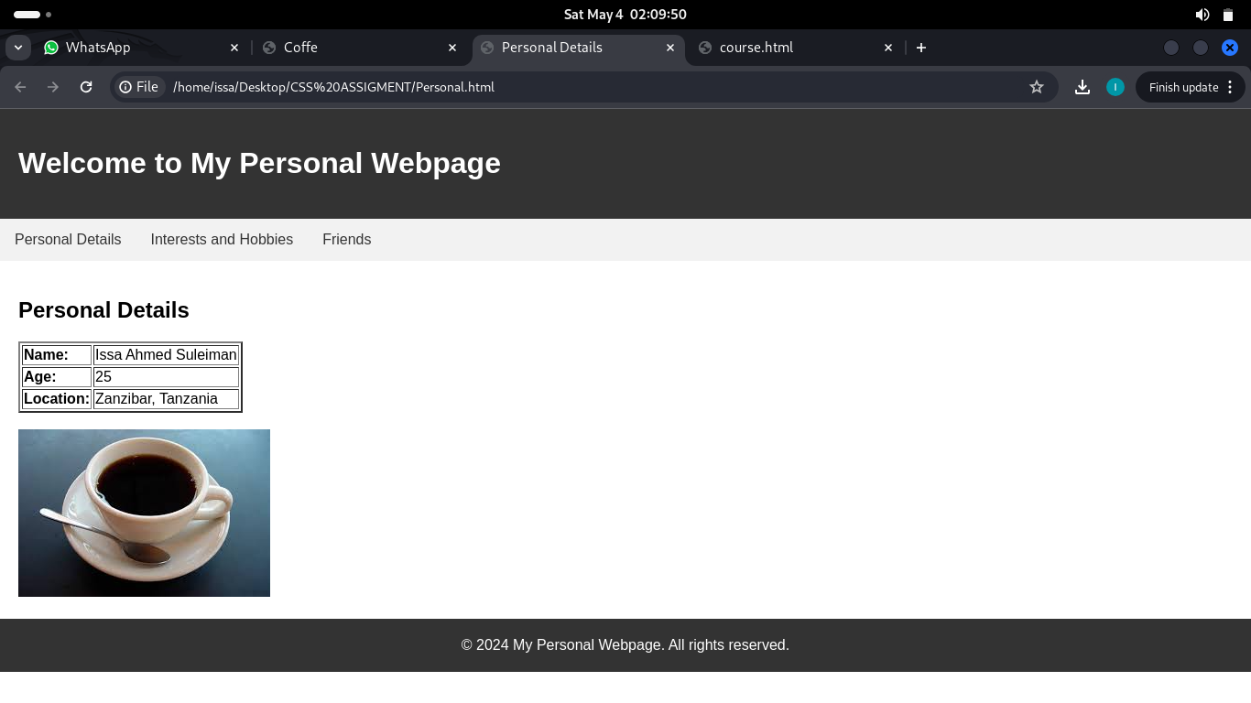
<!DOCTYPE html>
<html>
<head>
<title>Friends</title>
<link rel="stylesheet" type="text/css" href="pstyle.css">
</head>
<body>
<header>
<h1>Welcome to My Personal Webpage</h1>
</header>
<nav>
<ul>
<li><a href="Personal.html">Personal Details</a></li>
<li><a href="interest.html">Interests and Hobbies</a></li>
<li><a href="friend.html">Friends</a></li>
</ul>
</nav>
<main>
<h2>Friends</h2>
<p>Here are some of my friends:</p>
<ul>
<li>Mr Masoud</li>
<li>Mr Akram</li>
<li>Mr Hassan</li>
</ul>
</main>
<footer>
&copy; 2024 My Personal Webpage. All rights reserved.
</footer>
</body>
</html>

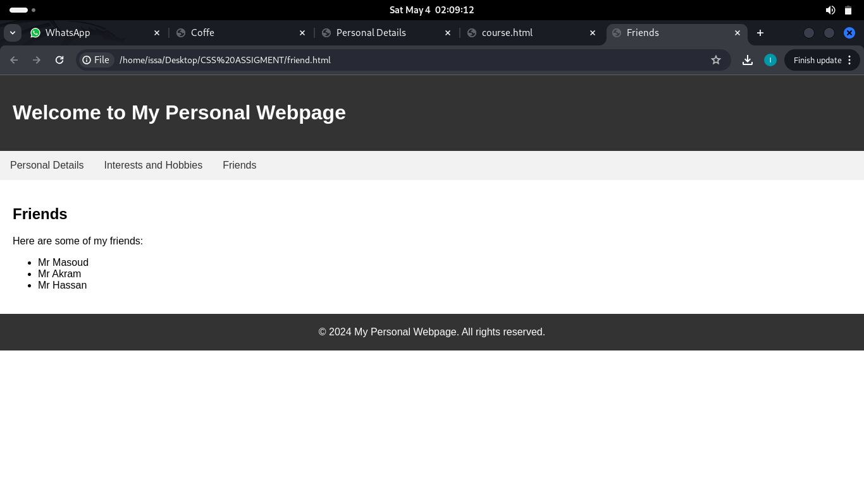

<!DOCTYPE html>
<html>
<head>
<title>Interests and Hobbies</title>
<link rel="stylesheet" type="text/css" href="pstyle.css">
</head>
<body>
<header>
<h1>Welcome to My Personal Webpage</h1>
</header>
<nav>
<ul>
<li><a href="Personal.html">Personal Details</a></li>
<li><a href="interest.html">Interests and Hobbies</a></li>
<li><a href="friend.html">Friends</a></li>
</ul>
</nav>
<main>
<h2>Interests and Hobbies</h2>
<ul>
<li>Reading</li>
<li>Hiking</li>
<li>Watching Football</li>
</ul>
</main>
<footer>
&copy; 2024 My Personal Webpage. All rights reserved.
</footer>
</body>
</html>

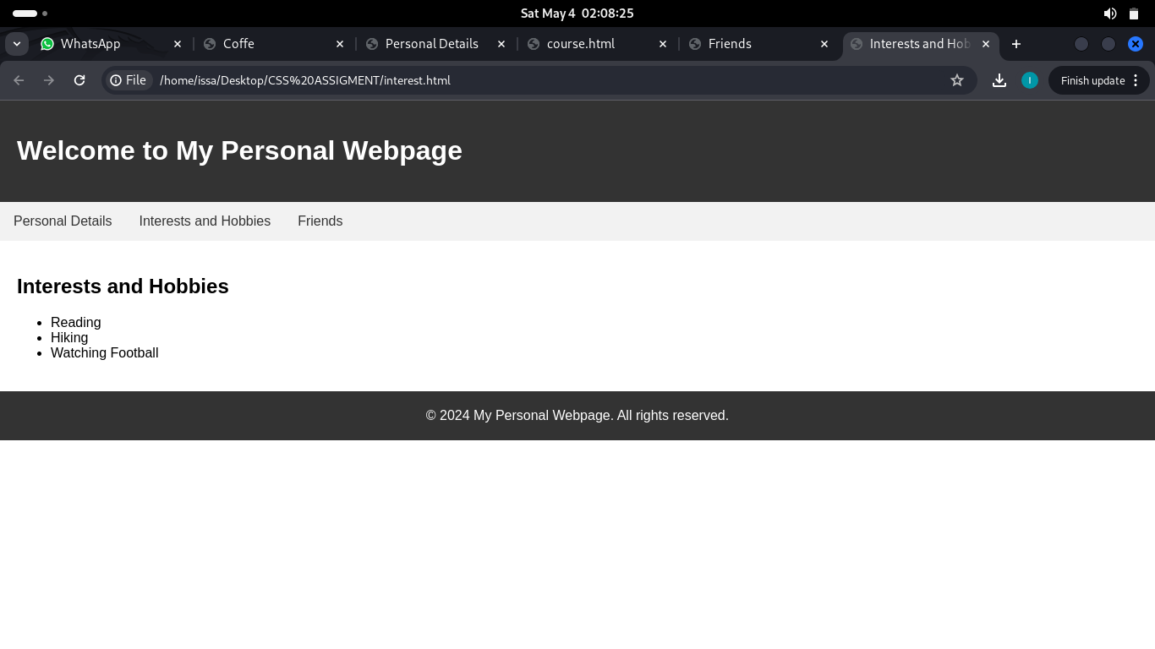
body {
font-family: Arial, sans-serif;
margin: 0;
padding: 0;
}
header {
background-color: #333;
color: #fff;
padding: 20px;
}
nav ul {
list-style-type: none;
margin: 0;
padding: 0;
overflow: hidden;
background-color: #f2f2f2;
}
nav ul li {
float: left;
}
nav ul li a {
display: block;
color: #333;
text-align: center;
padding: 14px 16px;
text-decoration: none;
}
nav ul li a:hover {
background-color: #ddd;
}
main {
padding: 20px;
}
footer {
background-color: #333;
color: #fff;
padding: 20px;
text-align: center;
}

4
<!DOCTYPE html>
<html>
<head>
<style>
body {
font-family: Arial, sans-serif;
}
h1 {
color: #333;
text-decoration: underline;
}
h2 {
color: #666;
}
ul {
list-style-type: disc;
margin-left: 20px;
}
ol {
list-style-type: decimal;
margin-left: 20px;
}
dl {
margin-top: 10px;
margin-bottom: 10px;
}
dt {
font-weight: bold;
}
dd {
margin-left: 20px;
}
</style>
</head>
<body>
<h1>Computer Science Course Tutorial Page</h1>
<h2>1. Introduction to Computer Science</h2>
<ul>
<li>Welcome Message</li>
<li>Course Overview</li>
<li>Learning Objectives</li>
<li>Course Structure</li>
</ul>
<h2>2. Module 1: Programming Fundamentals</h2>
<ol>
<li>
<h3>Topic 1: Introduction to Programming</h3>
<ul>
<li>Programming Languages</li>
<li>Variables and Data Types</li>
<li>Control Structures</li>
<li>Functions and Procedures</li>
</ul>
</li>
<li>
<h3>Topic 2: Object-Oriented Programming</h3>
<ul>
<li>Classes and Objects</li>
<li>Inheritance and Polymorphism</li>
<li>Encapsulation and Abstraction</li>
</ul>
</li>
</ol>
<h2>3. Module 2: Data Structures and Algorithms</h2>
<ol>
<li>
<h3>Topic 1: Data Structures</h3>
<ul>
<li>Arrays and Linked Lists</li>
<li>Stacks and Queues</li>
<li>Trees and Graphs</li>
<li>Hash Tables</li>
</ul>
</li>
<li>
<h3>Topic 2: Algorithms</h3>
<ul>
<li>Sorting and Searching</li>
<li>Recursion and Backtracking</li>
<li>Greedy Algorithms</li>
<li>Dynamic Programming</li>
</ul>
</li>
</ol>
<h2>4. Module 3: Databases and Web Development</h2>
<ol>
<li>
<h3>Topic 1: Database Management Systems</h3>
<ul>
<li>Relational Databases</li>
<li>SQL Queries and Joins</li>
<li>Normalization</li>
</ul>
</li>
<li>
<h3>Topic 2: Web Development</h3>
<ul>
<li>HTML and CSS</li>
<li>JavaScript and DOM Manipulation</li>
<li>Backend Development</li>
<li>Web Frameworks</li>
</ul>
</li>
</ol>
<h2>5. Module 4: Artificial Intelligence and Machine Learning</h2>
<ul>
<li>Introduction to AI and ML</li>
<li>Machine Learning Algorithms</li>
<li>Deep Learning and Neural Networks</li>
<li>Natural Language Processing</li>
</ul>
<h2>6. Module 5: Software Engineering and Project Management</h2>
<ul>
<li>Software Development Life Cycle</li>
<li>Agile Methodologies</li>
<li>Testing and Quality Assurance</li>
<li>Project Planning and Execution</li>
</ul>
</body>
</html>

